Stephen Re Activity 14.1

1



2

3

4

5

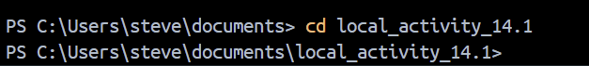

6



7

